EXP NO: 9

Basic Calculator App Using Android UI Controls

AIM:

Develop an Android application using controls like Button, TextView, EditText for designing a calculator having basic functionality like Addition, Subtraction, multiplication, and Division.

CODE:

MainActivity.kt

package com.example.myapplication_karthick_79

import android.os.Bundle

import android.view.View

import android.widget.Button   
import android.widget.EditText   
import android.widget.Toast

import androidx.appcompat.app.AppCompatActivity

class MainActivity : AppCompatActivity() {

private lateinit var display: EditText   
private var currentInput: String = ""   
private var operand1: Double = 0.0   
private var operand2: Double = 0.0   
private var operator: String = ""

override fun onCreate(savedInstanceState: Bundle?) { super.onCreate(savedInstanceState)

setContentView(R.layout.activity_main)

display = findViewById(R.id.display)

// Number buttons

setButtonClickListener(R.id.button0)   
setButtonClickListener(R.id.button1)   
setButtonClickListener(R.id.button2)   
setButtonClickListener(R.id.button3)   
setButtonClickListener(R.id.button4)   
setButtonClickListener(R.id.button5)   
setButtonClickListener(R.id.button6)   
setButtonClickListener(R.id.button7)   
setButtonClickListener(R.id.button8)   
setButtonClickListener(R.id.button9)

// Operator buttons

setOperatorClickListener(R.id.buttonAdd, "+")

setOperatorClickListener(R.id.buttonSubtract, "-")   
setOperatorClickListener(R.id.buttonMultiply, "*")   
setOperatorClickListener(R.id.buttonDivide, "/")

231801118 AI23431

// Clear button

findViewById<Button>(R.id.buttonClear).setOnClickListener { currentInput = ""

operand1 = 0.0   
operand2 = 0.0   
operator = ""

display.setText("")   
}

// Equal button

findViewById<Button>(R.id.buttonEqual).setOnClickListener { if (operator.isEmpty()) return@setOnClickListener

try {

operand2 = currentInput.toDouble()

val result = when (operator) {   
 "+" -> operand1 + operand2   
 "-" -> operand1 - operand2   
 "*" -> operand1 * operand2   
 "/" -> {

if (operand2 == 0.0) {

Toast.makeText(this@MainActivity, "Cannot divide by zero",

Toast.LENGTH_SHORT).show()

return@setOnClickListener   
}

operand1 / operand2   
}

else -> 0.0   
}

display.setText(result.toString())

operand1 = result // Update operand1 for subsequent calculations operator = ""

currentInput = result.toString() } catch (e: Exception) {

Toast.makeText(this@MainActivity, "Error: Invalid Input", Toast.LENGTH_SHORT).show()

}

}   
}

// Set up number button listeners

private fun setButtonClickListener(buttonId: Int) {   
 val button: Button = findViewById(buttonId)   
 button.setOnClickListener {

currentInput += button.text.toString()   
display.setText(currentInput)   
}

}

// Set up operator button listeners

private fun setOperatorClickListener(buttonId: Int, op: String) {   
 val button: Button = findViewById(buttonId)

231801118 AI23431

button.setOnClickListener {

if (currentInput.isNotEmpty()) {

operand1 = currentInput.toDouble() currentInput = ""

operator = op   
}

}   
}

// Optional: Add functionality to handle decimal point (if needed) private fun isDecimalPointValid(): Boolean {

return !currentInput.contains(".")

}

}

activity_main.xml

<?xml version="1.0" encoding="utf-8"?>

<LinearLayout xmlns:android=["http://schemas.android.com/apk/res/android](http://schemas.android.com/apk/res/android)"   
 xmlns:tools=["http://schemas.android.com/tools](http://schemas.android.com/tools)"

android:id="@+id/calculatorLayout"   
android:layout_width="match_parent"   
android:layout_height="match_parent"   
android:orientation="vertical"   
android:padding="16dp"   
tools:context=".MainActivity">

<EditText

android:id="@+id/display"

android:layout_width="match_parent"   
android:layout_height="80dp"   
android:background="#000000"   
android:textColor="#FFFFFF"   
android:textSize="28sp"

android:gravity="end|center_vertical" android:inputType="none"

android:focusable="false"   
android:clickable="false"   
android:padding="12dp"

android:layout_marginBottom="12dp" />

<!-- Row 1: 7 8 9 / -->

<LinearLayout

android:layout_width="match_parent"   
android:layout_height="wrap_content"   
android:orientation="horizontal">

<Button android:id="@+id/button7" style="@style/CalcButton" android:text="7" />   
<Button android:id="@+id/button8" style="@style/CalcButton" android:text="8" />   
<Button android:id="@+id/button9" style="@style/CalcButton" android:text="9" />

<Button android:id="@+id/buttonDivide" style="@style/CalcButton" android:text="/" /> </LinearLayout>

<!-- Row 2: 4 5 6 * --> <LinearLayout

231801118 AI23431

android:layout_width="match_parent"   
android:layout_height="wrap_content"   
android:orientation="horizontal">

<Button android:id="@+id/button4" style="@style/CalcButton" android:text="4" />   
<Button android:id="@+id/button5" style="@style/CalcButton" android:text="5" />   
<Button android:id="@+id/button6" style="@style/CalcButton" android:text="6" />

<Button android:id="@+id/buttonMultiply" style="@style/CalcButton" android:text="*" /> </LinearLayout>

<!-- Row 3: 1 2 3 - --> <LinearLayout

android:layout_width="match_parent"   
android:layout_height="wrap_content"   
android:orientation="horizontal">

<Button android:id="@+id/button1" style="@style/CalcButton" android:text="1" />   
<Button android:id="@+id/button2" style="@style/CalcButton" android:text="2" />   
<Button android:id="@+id/button3" style="@style/CalcButton" android:text="3" />

<Button android:id="@+id/buttonSubtract" style="@style/CalcButton" android:text="-" /> </LinearLayout>

<!-- Row 4: 0 C = + --> <LinearLayout

android:layout_width="match_parent"   
android:layout_height="wrap_content"   
android:orientation="horizontal">

<Button android:id="@+id/button0" style="@style/CalcButton" android:text="0" />

<Button android:id="@+id/buttonClear" style="@style/CalcButton" android:text="C" />   
<Button android:id="@+id/buttonEqual" style="@style/CalcButton" android:text="=" />   
<Button android:id="@+id/buttonAdd" style="@style/CalcButton" android:text="+" />   
</LinearLayout>

</LinearLayout>

styles.xml

<resources>

<style name="CalcButton">

<item name="android:layout_width">0dp</item>

<item name="android:layout_height">wrap_content</item> <item name="android:layout_weight">1</item>   
<item name="android:padding">16dp</item>   
<item name="android:textSize">24sp</item>

<item name="android:background">?attr/selectableItemBackground</item> <item name="android:textColor">#000000</item>

</style>

</resources>

231801118 AI23431

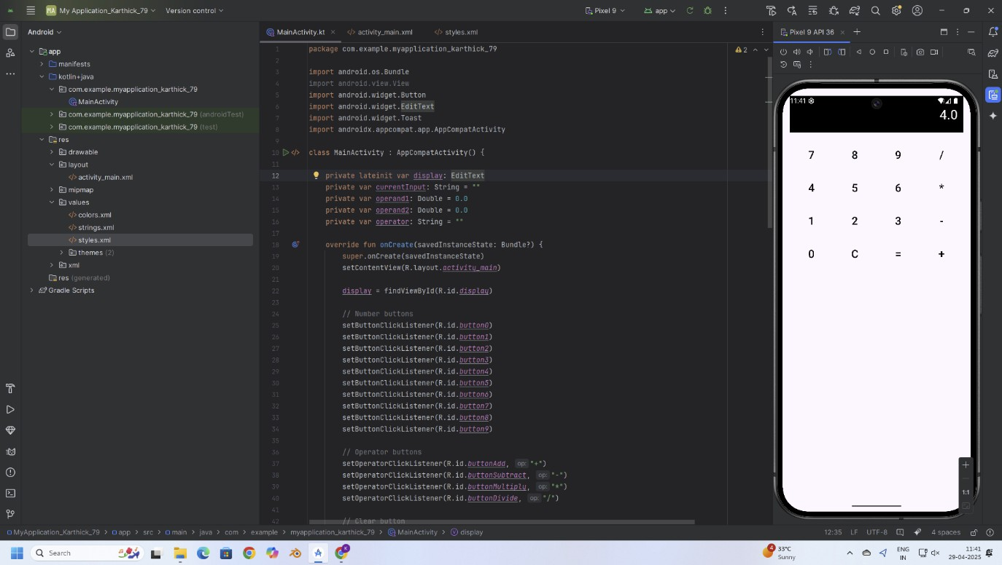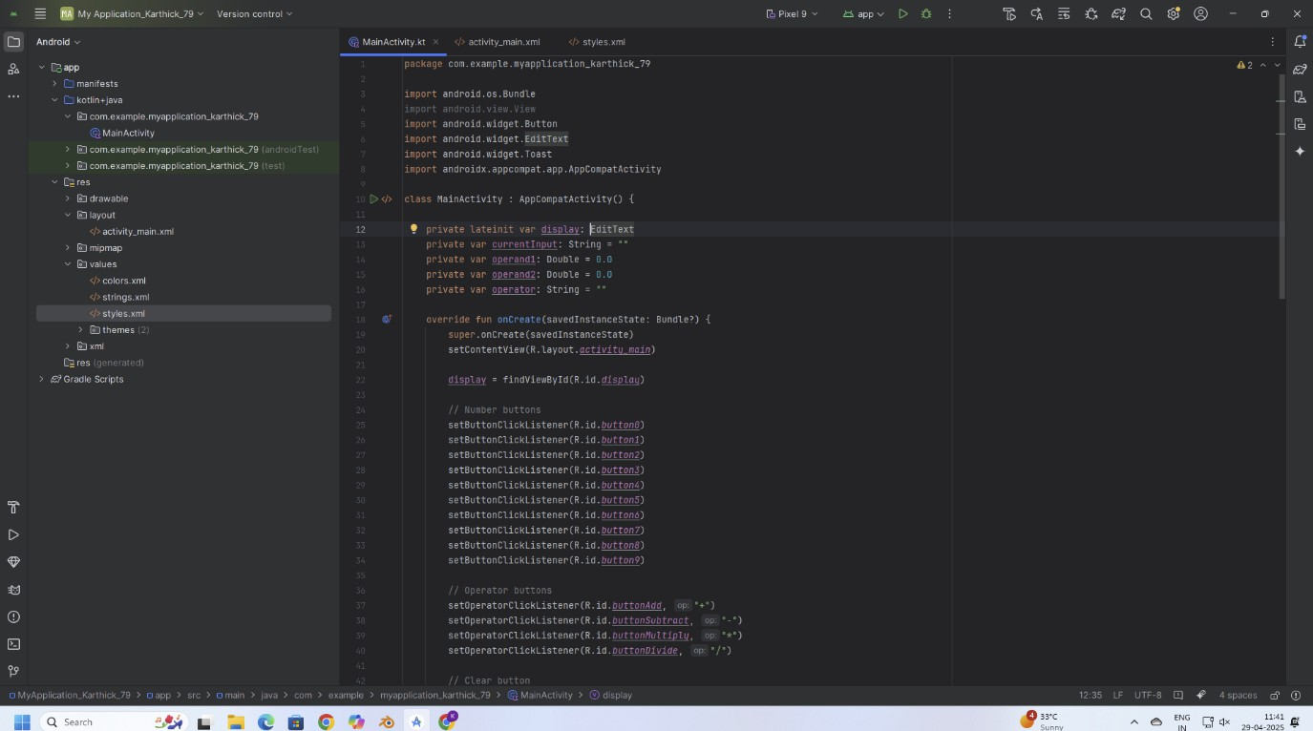

OUTPUT:

231801118 AI23431

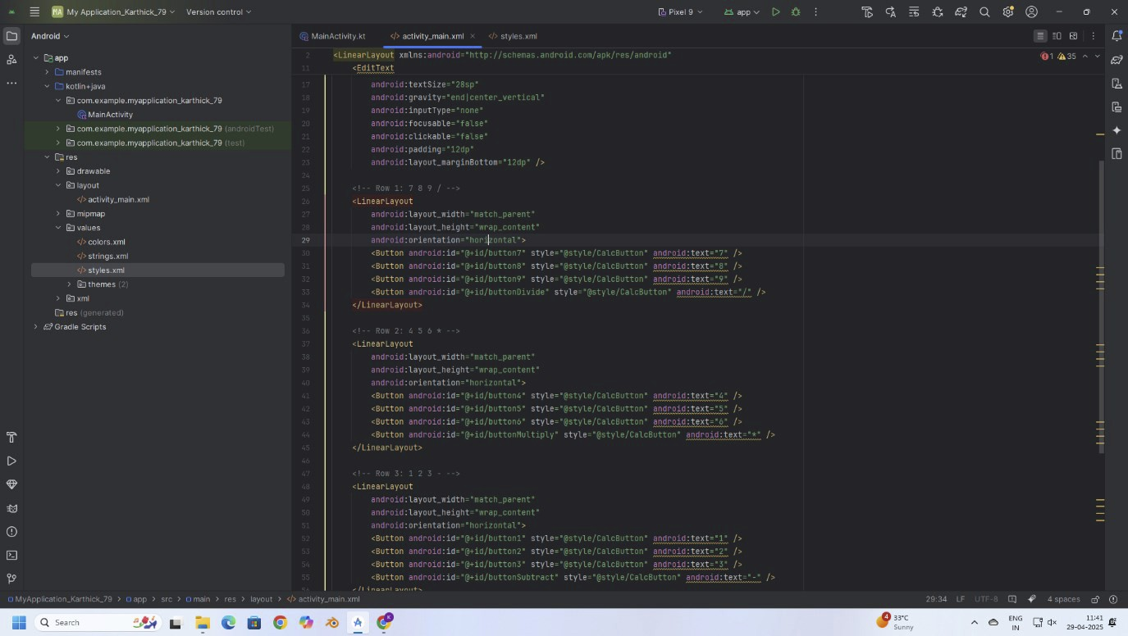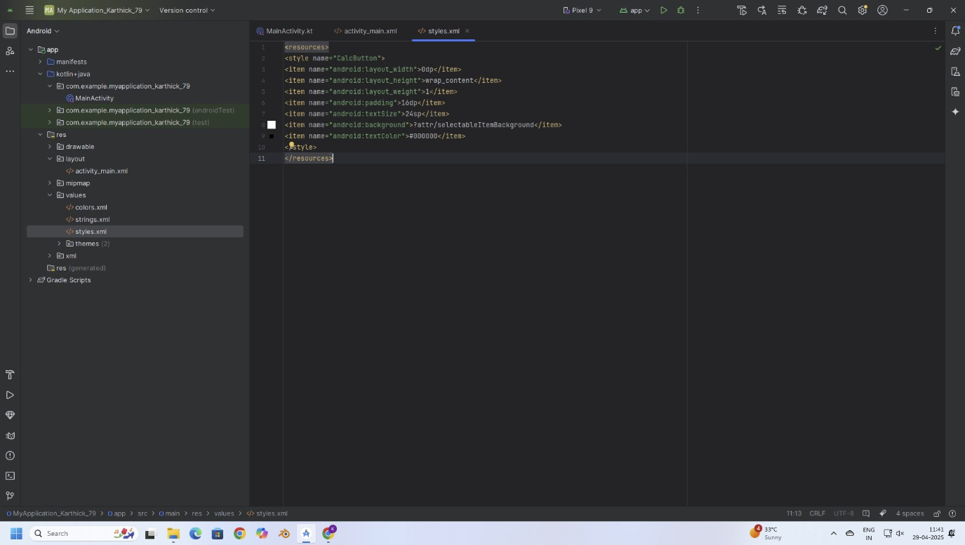

231801118 AI23431

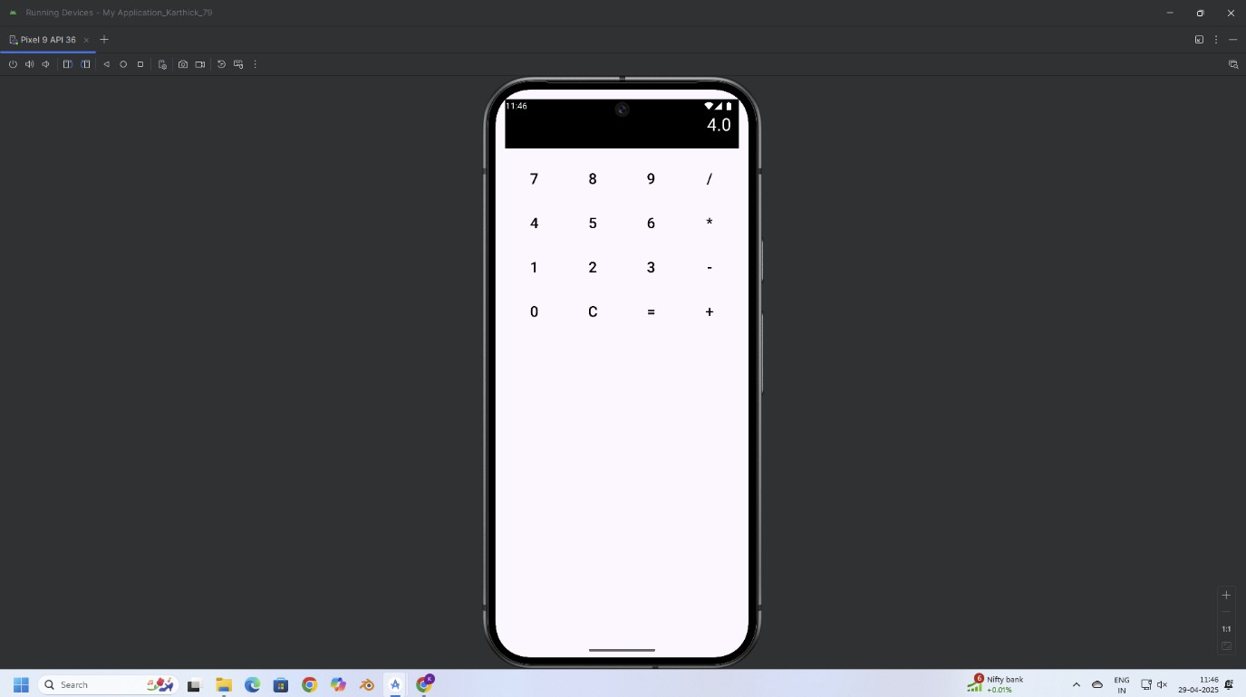

RESULT:

Thus, a basic calculator application was successfully developed using Android controls like   
Button, TextView, and EditText to perform addition, subtraction, multiplication, and division   
operations.

231801118 AI23431